Food Delivery Management System
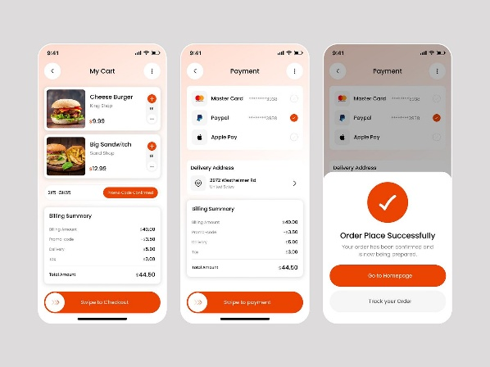
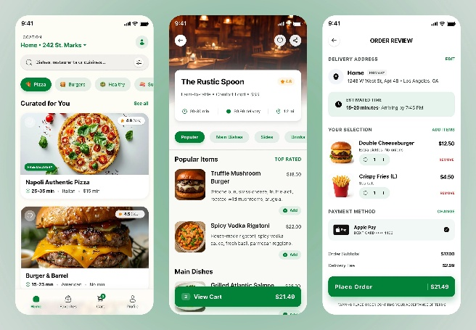

Objective: Develop a food delivery application using Python Object-Oriented Programming concepts.
Imagine you are developing a simplified version of Swiggy or Zomato.
The application should allow customers to:
- View available restaurants.
- Browse food items and their prices.
- Add food items to their cart.
- Place an order.
- Select a payment method.
- Choose a delivery option.
- Receive order confirmation.
The main objective is to understand how different OOP concepts work together in a real-world application, particularly Abstraction, Inheritance, Polymorphism and Encapsulation.
Problem Statement
A food delivery company wants to develop a Python-based application to manage its food ordering operations.
The company works with multiple restaurants, offers different payment methods and supports multiple delivery options.
You have been assigned the responsibility of developing this application.
Your application must follow a modular architecture using Python classes.

Project Architecture
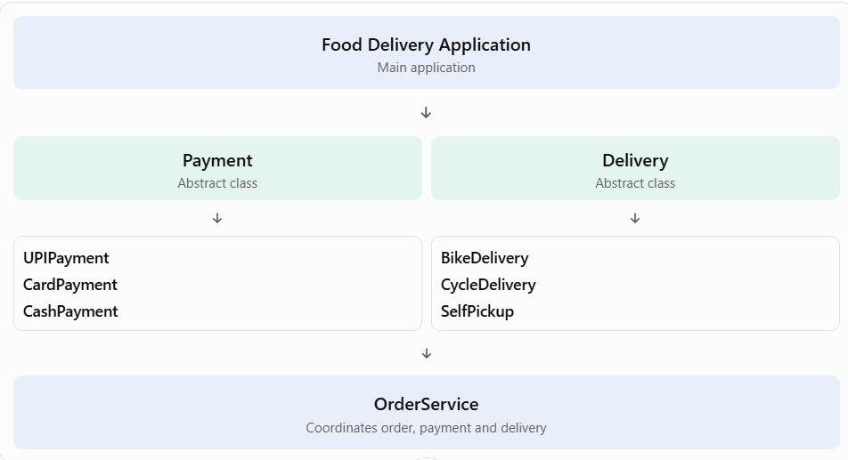
Functional Requirements
Module 1: Customer Management
Create a class named Customer.
Attributes:
- customer_id
- customer_name
- phone_number
- delivery_address
Methods:
- display_customer_details()
- update_address()
Requirements:
- Store customer information.
- Display customer details.
- Allow customers to update their delivery address.
Module 2: Restaurant Management
Create a class named Restaurant.
Attributes:
- restaurant_id
- restaurant_name
- location
- menu
Methods:
- display_restaurant_details()
- display_menu()
- add_food_item()
Requirements:
- Maintain restaurant details.
- Display available food items.
- Allow new food items to be added.
Each food item should have:
- Food ID
- Food name
- Price
- Category
Example menu:
Food Item | Category | Price
Pizza | Main Course | ₹250
Burger | Fast Food | ₹120
Pasta | Main Course | ₹180
Cold Coffee | Beverage | ₹100
Module 3: Shopping Cart
Create a class named Cart.
Attributes:
- cart_items
- total_amount
Methods:
- add_item()
- remove_item()
- view_cart()
- calculate_total()
Requirements:
- Add multiple food items.
- Remove food items.
- Display selected items.
- Calculate the total bill.
Module 4: Payment Management (Mandatory Abstraction)
Core OOP Requirement
Create an abstract class named Payment.
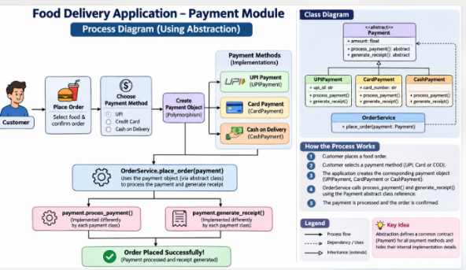
It should contain the following abstract methods:
Method | Purpose
process_payment() | Process customer payment
generate_receipt() | Generate payment receipt
Create the following child classes:
- UPIPayment
- CardPayment
- CashPayment
Each class must provide its own implementation of the abstract methods.
Business rules:
- UPI payment should accept a UPI ID.
- Card payment should accept a card number (use dummy data only).
- Cash payment should confirm that payment will be collected during delivery.
All payment classes must inherit from Payment.
Module 5: Delivery Management (Mandatory Abstraction)
Create an abstract class named Delivery.
It should contain the following abstract methods:
- calculate_delivery_charge()
- deliver_order()
Create the following child classes:
Class | Delivery Rules
BikeDelivery | Delivery charge ₹40
CycleDelivery | Delivery charge ₹20
SelfPickup | No delivery charge
Each child class must implement both abstract methods.
Module 6: Order Management
Create a class named Order.
Attributes:
- order_id
- customer
- restaurant
- cart
- payment
- delivery
- order_status
Methods:
- place_order()
- calculate_bill()
- display_order_details()
- update_order_status()
Requirements:
- Generate a unique order ID.
- Calculate the food amount.
- Calculate the delivery charge.
- Calculate the final payable amount.
- Process the selected payment.
- Generate a receipt.
- Update the order status.
Final bill formula:
Final Bill = Food Total + Delivery Charge
4. Application Workflow
The application should follow this sequence:
Start Application
Customer Registration / Login
Select Restaurant
View Menu and Select Food Items
Add Items to Shopping Cart
Calculate Total Amount
Select Payment
UPI / Card / Cash
Select Delivery
Bike / Cycle / Pickup
Process Payment and Delivery
Order Confirmed
Generate receipt and display order details
5. OOP Concepts to be implemented
Students must demonstrate the following concepts in their projects.
OOP Concept | Where to implement
Class and Object | Customer, Restaurant, Cart, Order
Constructor | Initialize object attributes
Encapsulation | Protect cart and account-related data
Inheritance | Payment and Delivery child classes
Abstraction | Payment and Delivery abstract classes
Polymorphism | Different payment and delivery implementations
Method Overriding | Child classes implement abstract methods
Composition | Order contains Customer, Cart, Payment and Delivery objects
6. Expected Project Folder Structure
Students should maintain a modular project structure instead of writing the entire application in one Python file.
FoodDeliveryApp/
│
├── main.py
│
├── models/
│ ├── customer.py
│ ├── restaurant.py
│ ├── food_item.py
│ ├── cart.py
│ └── order.py
│
├── payment/
│ ├── payment.py
│ ├── upi_payment.py
│ ├── card_payment.py
│ └── cash_payment.py
│
├── delivery/
│ ├── delivery.py
│ ├── bike_delivery.py
│ ├── cycle_delivery.py
│ └── self_pickup.py
│
└── services/
└── order_service.py
7. Expected Application Output
The application should produce output similar to the following:
Food Delivery Management System
Sample Output
Welcome to Food Delivery Application!
Customer Name: Rahul
Customer ID: 101

Available Restaurants:
1. Pizza House
2. Burger Point
3. Indian Kitchen

Select Restaurant: 1
----- MENU -----
1. Pizza Rs. 250
2. Burger Rs. 120
3. Pasta Rs. 180
4. Cold Coffee Rs. 100

Select Food Item: 1
Quantity: 2
Item added to cart!

----- YOUR CART -----
Pizza x 2 Rs. 500
Food Total: Rs. 500
Delivery: Rs. 40
-------------------------
Final Bill: Rs. 540

Select Payment:
1. UPI
2. Card
3. Cash

Select: 1
Select Delivery:
1. Bike
2. Cycle
3. Self Pickup

Select: 1

Processing UPI Payment...
Payment Successful!

Delivery assigned: Bike

Order ID: 1001
Order Status: Confirmed

Thank you for ordering!
Note: This is illustrative output. Students should design their own menus and interaction sequence.
8. Bonus Features (Optional)
For students who complete the basic application, introduce these additional requirements:
- Apply discount coupons.
- Add restaurant ratings.
- Allow customers to cancel orders.
- Add order history.
- Implement different delivery charges based on distance.
- Introduce a new payment method such as Wallet Payment.
- Add an abstract Notification class with Email and SMS implementations.
9. Evaluation Criteria
Evaluation parameter | Marks
Class design and constructors | 10
Encapsulation | 10
Inheritance | 15
Abstraction | 20
Polymorphism and overriding | 15
Application functionality | 15
Code organization and modularity | 10
Viva and explanation | 5
Total | 100
10. Viva Questions
Students should be able to answer:
- Why did you create Payment as an abstract class?
- Why can't we instantiate an abstract class?
- What happens if a child class does not implement all abstract methods?
- Why have you used inheritance in the payment module?
- How is polymorphism implemented in your application?
- What is the difference between abstraction and encapsulation?
- Why have you used composition in the Order class?
- Can we add a new payment method without modifying the existing OrderService?
- Can an abstract class have a constructor?
- What is the benefit of maintaining separate Python modules?
11. Submission Guidelines
Students must submit:
- Complete Python source code.
- Project folder with modular structure.
- Screenshots of successful execution.
- Class diagram or UML diagram.
- A short project report explaining OOP concepts used.
- Answers to the viva questions.

